**The Role of AI and Data Analytics in AT&T’s Business Strategy and Global Impact**

**Mihir Dharaiya, Sicheng Wan, Utkarsh Kothari and Shawn Njoroge**

**ALY 6060: Decision Support & Business Intelligence**

**January 14th, 2025**

**Contents**

Introduction 3

AT&T’s Data Analytics Culture 3

AI and Data Analytics in Product Offerings and Business Decision-Making 3

BI and Data Analytics’ Function in Decision-Making 4

Dashboard Interpretation and Insights 6

References 13

Appendix 14

**Table of Figures**

Figure a: Average Customer Retention Rate 14

Figure b: Top Service Type by Revenue 14

Figure c: Average Satisfaction Score: 14

Figure d: Average Revenue by Month: 15

Figure e: Customer Retention by Service Type 16

Figure f: Fraud Incidents by Region and Service Type 17

Figure g: AI Prediction Accuracy 17

Figure h: New Customer Acquisition Trends 18

# **Introduction**

To stay competitive in the ever-changing digital landscape of today, businesses need to leverage data analytics and artificial intelligence (AI). Leading telecoms company AT&T has made a name for itself as a data-driven company that uses AI to boost customer satisfaction, spur innovation, and streamline corporate processes. AT&T's dedication to data analytics and business intelligence (BI) is essential to preserving its leading position as Industry 4.0 transforms sectors throughout the globe. The data analytics culture at AT&T, the company's use of AI and BI to inform business choices and product offerings, the strategic ramifications of these technologies, and the organization's role in meeting global demands are all examined in this essay.

# **AT&T’s Data Analytics Culture**

AT&T incorporates AI and machine learning into many facets of its business operations, cultivating a strong data analytics culture. The business has created a framework for data-driven decision-making in which analytics are applied to improve cybersecurity, optimize consumer interaction, and expedite network operations. Real-time data processing, which enables predictive insights that enhance operational efficiency and service delivery, is a defining feature of AT&T's analytics culture (McDowell & Mallon, 2020). AT&T makes sure that its network architecture is flexible and responsive to consumer demands by utilizing enormous volumes of data.

AT&T also makes investments in ethical AI methods and data governance. The need for ethical AI deployment is growing as businesses depend more and more on AI. To make sure that its AI-driven choices adhere to moral principles and data protection laws, AT&T has created internal policies and compliance procedures (“Healthcare, Artificial Intelligence, Data and Ethics - A 2030 Vision,” 2018). Maintaining regulatory compliance and customer trust depend on this culture of responsible AI adoption.

**AI and Data Analytics in Product Offerings and Business Decision-Making**

AT&T uses AI and data analytics in a number of domains, such as cybersecurity, network management, and customer experience. By anticipating possible service interruptions and taking proactive measures to fix network problems, AI-powered algorithms assist the business in optimizing network performance. AT&T can identify irregularities and implement automated solutions to stop service interruptions by examining large datasets from network traffic (Schwab, 2023). Predictive maintenance lowers operating costs while improving network reliability.

AT&T uses virtual assistants and chatbots powered by AI to provide individualized customer service. In order to provide personalized recommendations and expedite issue resolution, these technologies examine past data, consumer encounters, and preferences. By reducing human intervention, AI in customer service not only improves user pleasure but also lowers operational inefficiencies (“Resources for Hiring and Retaining the Best Talent for Federal Agencies,” 2021).  
  
In order to protect data integrity and stop cyberattacks, AT&T also incorporates AI into its cybersecurity system. AI-based threat detection systems keep an eye on network activity all the time, spotting any security lapses and reducing threats instantly. AI-driven security solutions are essential for safeguarding private consumer information and preserving the integrity of AT&T's digital infrastructure in light of the growing complexity of cyberthreats (Galaz, 2021).

**BI and Data Analytics’ Function in Decision-Making**  
AT&T is able to make more strategic and well-informed decisions thanks to business intelligence and data analytics. AT&T can create focused marketing campaigns and improve pricing tactics by examining patterns in consumer behavior. By using predictive analytics, the business can foresee market trends and make proactive changes to its service offerings (McDowell & Mallon, 2020). AT&T is better equipped to stay competitive in the rapidly changing telecom industry because to this data-driven strategy.  
  
Additionally, by tracking key performance indicators (KPIs) across several divisions, BI technologies assist AT&T in evaluating operational effectiveness. AT&T executives can make quick decisions by visualizing performance measures in real time by combining data from several sources. Additionally, supply chain optimization is supported by data analytics, which guarantees that resources are distributed effectively to satisfy customer expectations (“Healthcare, Artificial Intelligence, Data and Ethics - A 2030 Vision,” 2018).

Greater automation in data analysis is made possible by AT&T's investment in AI-driven BI solutions, which lessens the need for manual procedures. Because of this automation, AT&T can handle large volumes of data rapidly, increasing the accuracy of its decisions and speeding up its reaction to changes in the market (Schwab, 2023). As a result, AT&T continues to lead the way in both service quality and technological innovation.  
  
**AT&T's Prospects for the Fourth Industrial Revolution**  
In order to stay at the forefront of Industry 4.0, AT&T needs to adjust to new technologies. The combination of automation, the Internet of Things (IoT), and artificial intelligence (AI) is what defines the Fourth Industrial Revolution and opens up new avenues for digital transformation (Schwab, 2023). AT&T needs to increase its capabilities and further incorporate AI-driven automation into its core operations in order to stay ahead.

Enhancing its 5G infrastructure is a key priority for AT&T since it will facilitate quicker connectivity and meet the increasing demand for IoT applications. Network optimization driven by AI will be essential to the smooth rollout of 5G, improving connectivity for both consumers and enterprises. To stay abreast of technical developments, AT&T must also keep funding AI research and development (Galaz, 2021).  
  
AT&T must also maintain its focus on worker development if it hopes to succeed in Industry 4.0. AT&T must make investments in upskilling staff members to adjust to new technology settings as automation and artificial intelligence transform employment positions. To give workers the skills they need to spur innovation, training programs in artificial intelligence, data science, and cybersecurity will be crucial (“Resources for Hiring and Retaining the Best Talent for Federal Agencies,” 2021).

# **Dashboard Interpretation and Insights**

With an emphasis on revenue, customer retention, customer satisfaction, and AI performance, the AT&T Business Performance Dashboard offers a thorough summary of the company's primary business KPIs. The dashboard's primary metrics and visuals are explained in detail below:

**1. Average Customer Retention Rate**

The entire customer retention rate for all of AT&T's services is represented by *Figure a*. Given its direct correlation to customer loyalty, service quality, and long-term economic performance, AT&T views customer retention as a critical statistic. With over 86% of consumers opting to stick with AT&T over time, the company's average customer retention rate of 85.97% indicates that it is performing well at keeping its clients. It is far less expensive to keep current customers than to get new ones, and high retention rates are usually an indicator of competitive pricing, excellent customer satisfaction, and efficient customer service (McDowell & Mallon, 2020).

The degree to which AT&T's services are fulfilling consumer expectations can also be inferred from this retention rate. The high proportion suggests that most customers are satisfied with AT&T's service offerings, which include bundled packages, customer assistance, and network dependability. Nevertheless, AT&T still has room to grow despite its comparatively high retention rate. In order to find any areas where the service can fall short of expectations, the business must constantly interact with its clients and solicit their opinions. For instance, there can be a chance to improve the customer experience or implement loyalty programs if customers are staying but are not really involved (Schwab, 2023).

Another sign that AT&T's pricing policies and promotional offers are successful in preserving customer loyalty is the company's 85.97% retention rate. According to the dashboard, users seem to particularly enjoy bundled services, which implies that AT&T's attempts to combine services like TV, internet, and wireless are quite effective in gaining the loyalty of long-term customers. Given the escalating competition in the telecommunications industry, AT&T will need to maintain this high retention rate.

**2. Top Service Type by Revenue**

For AT&T, the "bundled" service is the one that generates the most income as seen in *Figure b*. The value that consumers have on bundled packages that provide a variety of services, such TV, internet, and wireless, is highlighted by this research. Because it gives consumers the ease of managing several services through a single provider and frequently results in cost savings as compared to buying each service separately, bundling is a common tactic in the telecom sector (Schwab, 2023).  
  
Bundled services are beneficial from a commercial standpoint because they assist retain consumers for extended periods of time in addition to increasing average revenue per user (ARPU). Customers are less likely to go to a competitor when they have several subscriptions since they are more integrated into the provider's ecosystem. By emphasizing bundled services, AT&T is able to take advantage of cross-selling and upselling opportunities, resulting in a more complete offering that meets a wide range of customer needs.

Additionally, AT&T is able to take advantage of economies of scale through bundling. The business can continue to be profitable while providing services to customers at a reduced cost by bundling them together. Customers could be persuaded to purchase more services than they had planned because, for example, they believe that buying a bundle at a lower price is valuable.  
  
In the telecommunications industry, businesses are increasingly emphasizing integrated solutions over isolated services, which is consistent with the focus on bundled services. Maintaining this revenue stream and raising customer happiness will depend on AT&T's capacity to keep developing its bundles as consumer needs change, maybe by including more flexible or customizable alternatives (Galaz, 2021).

**3. Average Satisfaction Score**

At 8.20 out of 10 (see *Figure c*), the average customer satisfaction rating is comparatively good but there is still room for improvement. The high score indicates that most consumers perceive AT&T's products, including its internet, wireless, and bundled packages, to be valuable. AT&T may be able to improve its services in a few areas, though, given that the score is not closer to 10.  
  
Additionally, the 8.20 satisfaction rating offers insightful information about the client experience. It implies that even though AT&T is generally fulfilling customer expectations, satisfaction might be raised in certain service categories, geographical areas, or clientele groups. For instance, AT&T might concentrate on improving particular services, like TV or internet, by increasing network dependability, lowering customer support issues, or providing more affordable pricing plans if these services have lower satisfaction ratings than wireless.

For AT&T, the satisfaction rating is a crucial indicator since it affects both acquiring new customers and keeping hold of current ones. Reviews and satisfaction scores are frequently used by potential clients to inform their choices. To raise this rating and set itself apart from rivals, AT&T needs to concentrate on resolving any areas of discontent. To cut down on wait times and enhance problem solving, AT&T might, for instance, consider introducing more efficient customer care procedures or offering more training in customer service.  
  
Additionally, as the telecom industry becomes more competitive, customer satisfaction emerges as a crucial distinction. Higher satisfaction ratings may result from AT&T introducing more individualized services and loyalty plans. Additionally, integrating AI-powered solutions to provide personalized recommendations or improve issue resolution might also enhance the overall customer experience.

**4. Revenue Trend (Average Revenue by Month)**

Monthly revenue is shown in the line graph, which peaks in March 2024 and subsequently declines in July 2024 (see *Figure d*) implying that seasonal variations in AT&T's revenue occur. Numerous reasons, such as shifts in consumer behavior, promotional times, or the introduction of new goods or services, could be responsible for these developments.  
  
Marketing campaigns, seasonal incentives, or even brand-new customer acquisition programs that AT&T introduced at the time could have contributed to the income rise in March 2024. Seasonal peaks are typical in sectors such as telecommunications, where customers are encouraged to add new services, upgrade packages, or make service changes by advertising or discounts around holidays or other times of the year. For AT&T to effectively plan its marketing, sales, and resource allocation plans, it is essential to comprehend the seasonal patterns in revenue.

For example, AT&T can modify its marketing and sales strategies to increase business during customarily quiet times if it discovers that its revenue peaks in March and dips in the summer months (such as July). To offset any drops in revenue during certain periods, AT&T might wish to introduce targeted advertising, loyalty programs, or special service packages. In a similar vein, the business should make sure that customer retention initiatives are strengthened in order to ensure that clients remain after taking advantage of seasonal incentives, maximizing the revenue rise during peak months.  
  
The monthly revenue trends also give AT&T information about how well their pricing plans are working. If the company's revenue fluctuates frequently, it could be time to review its service offerings, product bundling, or pricing changes.

**5. Customer Retention by Service Type**

*Figure e* shows the distribution of customer retention rates across various service types. In terms of client retention, no single service offering performs noticeably better than the others, as evidenced by the nearly similar distribution of retention rates across service categories. This indicates that AT&T's offerings are comparatively well-balanced in terms of patronage.  
  
Nevertheless, bundled services have the highest retention rate (25.73%), indicating that customers are more inclined to stick with a subscription that includes many services than individual products. Because it offers consumers convenience, financial savings, and a more complete service package, bundling is a popular tactic in the telecom sector.

The retention rate for TV services is 24.1%, which is lower than that of bundled services but still rather high. This might point to a chance for AT&T to enhance the caliber or add more features to its TV lineup in order to boost customer retention in this market. In a similar vein, AT&T's wireless services, which make up 24.81% of the retention rate, are an essential component of its offerings, and any drops in customer happiness or service dependability might cause this percentage to drop.  
  
All things considered, the comparatively even distribution of customer retention across services indicates that AT&T's clientele has a wide range of requirements and tastes. To target particular client segments, the business would wish to think about launching more customized service offerings or bundles. Additionally, AT&T could concentrate on enhancing TV and wireless services if the retention rate starts to decline in the future in order to preserve its dominant position in all markets.  
  
AT&T should keep highlighting the benefits of bundles while making sure that separate services like TV and wireless are not overlooked. Marketing campaigns could be created to demonstrate to consumers the advantages of switching to bundled packages. Personalized upgrade offers or reward programs may assist boost the retention rate of clients on individual services.

**6. Fraud Incidents by Region and Service Type**

Each service type (bundled, internet, TV, and wireless) is represented by a distinct hue in the Fraud occurrences by Region and Service Type visualization (see *Figure f*), which is a stacked bar chart that displays the number of fraud occurrences reported across the South and Northeast regions.

Knowing which service types are most vulnerable to fraudulent behavior and where fraud events are most common requires a comprehension of this graphic. The data shows that while the South and Northeast regions have a fairly equal number of fraud events, the South appears to have more cases overall, especially in the Bundled and Wireless sectors.  
  
There are more fraud cases involving bundled services in the South, which may be a sign of weaknesses in the way these services are packaged or the way client data is handled there. Given the prevalence of fraud in wireless services, AT&T may need to strengthen its security protocols for account management, billing, and new sign-ups.

For any telecoms company, fraud is a serious problem since it can result in monetary losses, a tarnished reputation, and unhappy customers. Although fraud occurs in all regions, the regional breakdown shows that it is more prevalent in the South, pointing to possible flaws in the security or fraud prevention procedures there.  
In the South, where instances seem to occur more frequently, AT&T should think about strengthening its fraud prevention systems, particularly for Bundled and Wireless services. This can entail strengthening fraud detection algorithms, putting in place more robust account protection features, and increasing identity verification procedures. Furthermore, teaching consumers how to spot and report fraudulent activity may help to lower the frequency of occurrences.

**7.** **AI Prediction Accuracy**

The AI prediction accuracy for each service type in the Northeast and South areas is listed in the AI Prediction Accuracy table (see Figure g**)**. According to the data, forecast accuracy varies slightly depending on the kind of service; the best accuracy is found in Bundled services, particularly in the Northeast (94.17%).  
  
Since it shows how well AI models can predict consumer behavior, service demand, and network requirements, AI prediction accuracy is an important indicator for AT&T. A high prediction accuracy means AT&T's AI models are doing a good job of anticipating consumer needs and streamlining service delivery. Consequently, AT&T is able to improve customer satisfaction and boost operational effectiveness.

For Bundled services in particular, the Northeast region has higher accuracy across most service types, indicating that either more data is available for training in that region or the AI models have been fine-tuned there. However, the accuracy is marginally lower in the South, especially for TV services (85.37%). This can suggest that there is less data available or that the AI models for TV providers in the South are less developed.  
  
AT&T should keep refining its AI models to forecast consumer demand and behavior. There is room for improvement due to the South (TV) service type's marginally inferior accuracy. The forecast could be improved by expanding the amount of data used to train AI models for this service or by improving the model methods.

**8. New Customer Acquisition Trends**

The percentage of new customers acquired between January and July of 2024 is displayed in the New Customer Acquisition Trends visualization (see *Figure h*). According to the patterns, client acquisition is steady, with minor variations in some months.  
  
The effectiveness of AT&T's customer base expansion is shown in the New Customer Acquisition Trends chart. The steady pattern over the course of the months shows that AT&T is continuously gaining new clients, which is essential to the expansion of the business. However, some marketing efforts, special offers, or seasonal trends that increase consumer interest may be the cause of certain variations in client acquisition, especially in March 2024.

The consistent acquisition rate indicates that AT&T's sales and marketing initiatives are working, but the business needs to continue to be on the lookout to make sure that customer acquisition stays consistent over time. AT&T may need to modify its strategy to draw in new clients if acquisition slows off. This could involve focusing on underserved markets or providing incentives for customers to transfer to AT&T services.  
  
AT&T should keep an eye on client acquisition trends and determine what causes monthly variations. AT&T may repeat similar marketing initiatives in the future if a particular offer in March 2024 results in higher acquisition. Focusing on keeping new clients is also crucial since, in order to optimize long-term business growth, high customer acquisition rates must be combined with effective retention tactics.

# **References**

Galaz, V. (2021, May 4). Will the Fourth Industrial Revolution serve sustainability? *The Kathmandu Post*. https://kathmandupost.com/columns/2021/05/04/will-the-fourth-industrial-revolution-serve-sustainability

Healthcare, Artificial Intelligence, Data and Ethics—A 2030 Vision. (2018). *Digital Europe*. https://digital-europe-website-v1.s3.fr-par.scw.cloud/uploads/2019/02/Healthcare-AI-Data-Ethics-2030-vision.pdf

McDowell, T., & Mallon. (2020). Getting decision rights right. *Deliotte Insights*. https://www2.deloitte.com/us/en/insights/topics/talent/organizational-decision-making.html

Resources for Hiring and Retaining the Best Talent for Federal Agencies. (2021). *Management Concepts*. https://managementconcepts.com/resource/resources-for-hiring-and-retaining-the-best-talent-for-federal-agencies/

Schwab, K. (2023). *The Fourth Industrial Revolution* (Encyclopædia Britannica). Britannica. https://www.britannica.com/topic/The-Fourth-Industrial-Revolution-2119734

# **Appendix**

Figure a: Average Customer Retention Rate

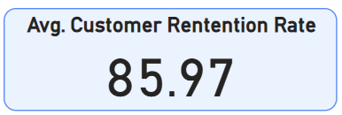

Figure b: Top Service Type by Revenue

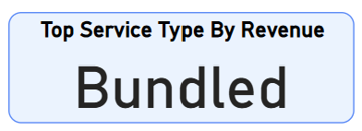

Figure c: Average Satisfaction Score:

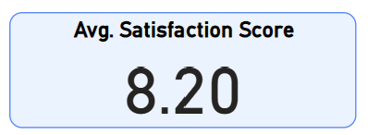

Figure d: Average Revenue by Month:

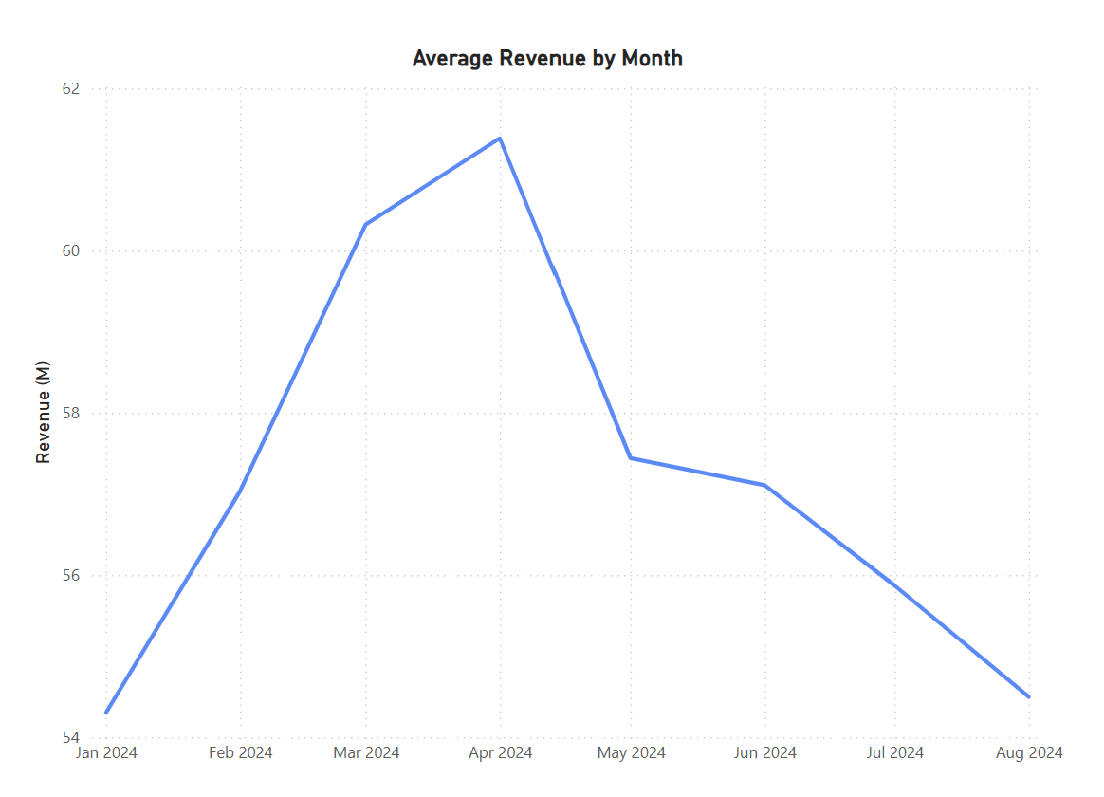

Figure e: Customer Retention by Service Type

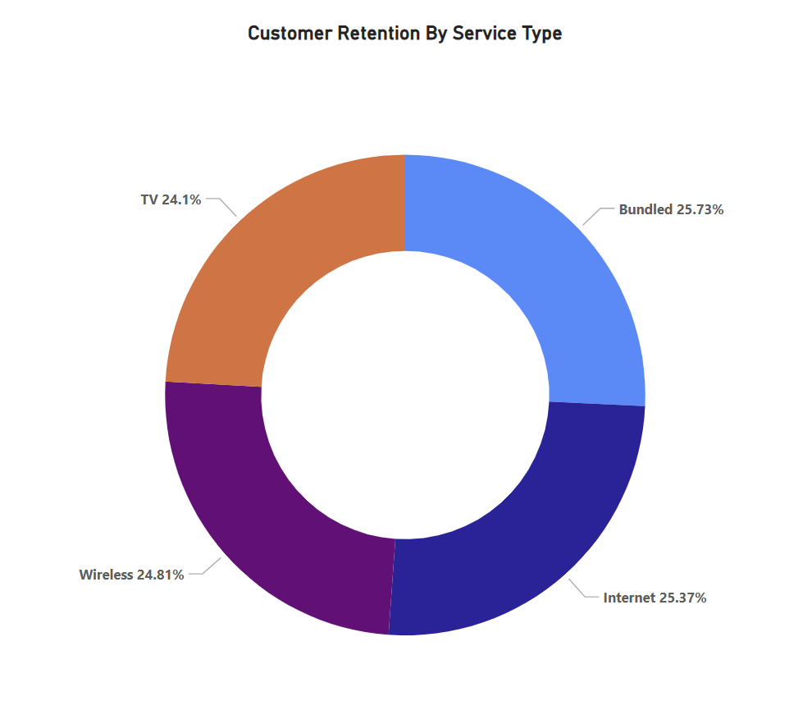

Figure f: Fraud Incidents by Region and Service Type

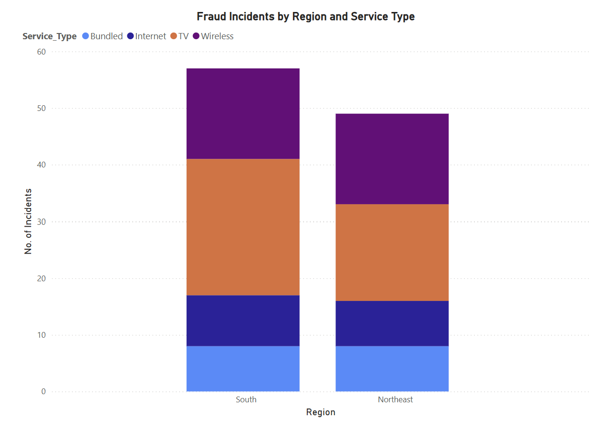

Figure g: **AI Prediction Accuracy**

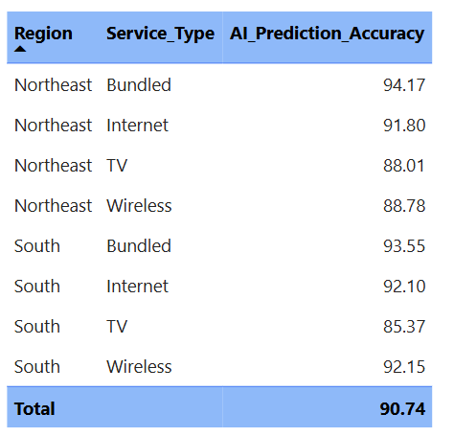

Figure h: New Customer Acquisition Trends

